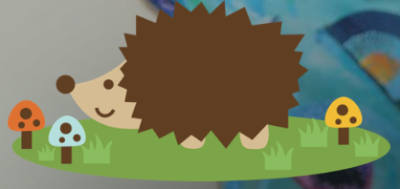
Mickleton Primary School

Maths

Intent and Implementation

Progression of Knowledge and Skills for Maths

Maths Curriculum Intent Statement:
For every child to develop as independent, confident and successful learners with high aspirations to achieve in mathematics. We are focused on ensuring children have a sound understanding of Maths, equipping them with the skills of calculation, reasoning and problem solving that they need in life beyond school. Our primary objective is for the children to become confident, fluent and agile mathematicians. From Early Years the children are introduced to number and calculating, and this is constantly taught and practised until the end of Year 6. The children apply these strong number skills to problems which they are able to solve with solid reasoning. These skills are taught so they are naturally transferrable to everyday life and meaningful to the children.
Our curriculum intent includes planned opportunities to:
- Promote enjoyment and enthusiasm for learning through practical activity, exploration and discussion
- Ensure children have access to a high-quality maths curriculum that is both enjoyable and challenging
- Provide children with activities that enable them to make connections between concepts and explore at a greater depth
- Develop mathematical knowledge, skills and vocabulary
- Develop mental-maths skills including recall of basic number facts
- Promote confidence and competence with numbers and the number system
- Develop the ability to solve problems through decision-making and reasoning in a range of contexts including through other curriculum lessons
- Explore features of shape and space, and develop measuring skills in a range of contexts
- Understand the importance of mathematics in everyday life and be given the opportunity to apply what they have learnt to real life situations
- Develop independence and inquisitive minds
Maths Curriculum Implementation:
The maths curriculum follows the National Curriculum objectives for each year group. We use ‘Times Table Rockstars’, ‘The 99 club’ and ‘Big Maths’ tests to develop children’s mental and written mathematical skills. Calculation policies ensure progression throughout the school in addition, subtraction, multiplication and division methods and provide staff with a clear picture about what has learnt before and what will be covered next. We ensure there are opportunities to develop maths skills through many other curriculum areas, when planning theme questions opportunities to further apply maths skills are included on medium term plans.
The school is well equipped with resources to support the teaching of Maths. Children have constant access to and are able to use a range of concrete apparatus during lessons to scaffold and extend their learning. Monitoring of the curriculum area is carried out by the Senior Leadership Team as well as the subject lead. Regular learning walks, observations, pupil progress meetings, book looks, termly assessments, Insight and discussions with pupils all form part of the monitoring schedule.
There are regular whole school competitions held internally for all children. Number facts and times tables are encouraged to be learnt at home with home learning being supported by our subscription to Times Tables Rockstars. Each class also has a maths area with relevant challenges which the children can either complete in the class or at home.
Early Years Foundation Stage
Developing a strong grounding in number is essential so that all children develop the necessary building blocks to excel mathematically. Children should be able to count confidently, develop a deep understanding of the numbers to 10, the relationships between them and the patterns within those numbers. By providing frequent and varied opportunities to build and apply this understanding - such as using manipulatives, including small pebbles and tens frames for organising counting - children will develop a secure base of knowledge and vocabulary from which mastery of mathematics is built. In addition, it is important that the curriculum includes rich opportunities for children to develop their spatial reasoning skills across all areas of mathematics including shape, space and measures. It is important that children develop positive attitudes and interests in mathematics, look for patterns and relationships, spot connections, ‘have a go’, talk to adults and peers about what they notice and not be afraid to make mistakes.
ELG: Number
Children at the expected level of development will:
- Have a deep understanding of number to 10, including the composition of each number; 1- 4
- Subitise (recognise quantities without counting) up to 5;
- Automatically recall (without reference to rhymes, counting or other aids) number bonds up to 5 (including subtraction facts) and some number bonds to 10, including double facts.

ELG: Numerical Patterns
Children at the expected level of development will:
- Verbally count beyond 20, recognising the pattern of the counting system;
- Compare quantities up to 10 in different contexts, recognising when one quantity is greater than, less than or the same as the other quantity;
- Explore and represent patterns within numbers up to 10, including evens and odds, double facts and how quantities can be distributed equally.

Maths lessons are taught each day and are organised as follows in KS1 and KS2:
Monday-Thursday: 5 Mins flashback (FB4) warm up (White Rose Hub), Main session following objectives from the National Curriculum that include fluency, problem solving and reasoning, but focusing on the fluency element of each skill initially. Planning is taken from White Rose.
Fluency Sessions: Each day, focusing on the small steps of fluency (see list at the end of this document) Resources: Fluency Bee, TT Rockstars and various online resources, depending on year group and cohort.
Every Friday: Teaching of reasoning and problem solving, using White Rose, I See Reasoning, Nrich and NCETM resources as necessary.
Last Friday of each Month: low stakes AFL - 99 clubs and Big Maths CLIC are – Year two onwards from Autumn term, Year one from Spring term.
In our Early Years, mathematical opportunities are provided through continuous provision along with daily whole class teaching.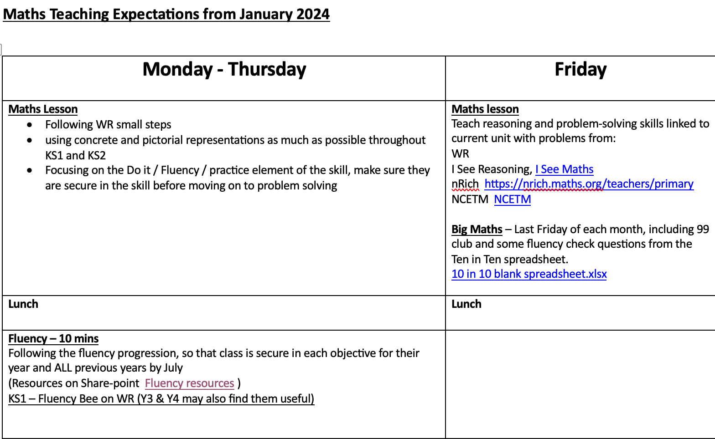

Planning
Long term planning: National Curriculum and Development Matters objectives, Calculation Policy for KS1 and KS2.
Medium Term: Overview showing which concepts are covered throughout the school year.
For medium term planning, teachers use the objectives set for their year group using the National Curriculum and White Rose objectives. The objectives from each term are clear and progression within each year group is evident as well as common vocabulary and methods which are built upon as the children move through the school. Each year group follows their calculation policy to ensure progression from year to year - this is in line with the strategies from the 2014 National Curriculum.
“Big Maths” Friday will also be an opportunity to assess mental maths skills through ’99 clubs’ and ‘CLIC’ tests. Mental maths skills will be practised daily and assessed, with results recorded to identify progression.
Assessment Guidance
At Mickleton Primary, there is a belief that effective assessment provides valuable information to inform and improve teaching and learning thereby raising standards. Our aim therefore, is to ensure that all staff, children and parents are all working together. In order to achieve this, the children are encouraged to take an active role in assessing their own learning and staff feedback regularly to all pupils so that they know and understand what they need to do to next in order to make further progress. Parents also receive regular verbal and written reports about their children’s learning thus, creating strong and positive relationships within and between school and the wider community.
Aims and Objectives
The aims and objectives of assessment in our school are:
- To enable our children to demonstrate what they know and understand in their work.
- To help our children to recognise and understand what they need to do next to improve their work and make their ‘next steps’ of progress.
- To allow teachers to plan work that accurately reflects the needs of each child.
- To provide regular information for parents that enable them to support their child’s learning.
- To provide the Headteacher and Governors with information that allows them to make judgements about the effectiveness of the school.
- To have high expectations of success, with all pupils expected and encouraged by all staff and parents to achieve their potential.
- To evaluate progress by analysing assessment results to keep track of the relative performance and attainment of different groups and to tackle underperformance by any particular group.
- To ensure each child is able to ‘enjoy and achieve’ through making personal developmental steps and attaining stretching national educational standards at primary school.

Planning for Assessment
We use the national curriculum key skills and our school’s curriculum maps to guide our teaching. The curriculum maps detail the units of work to be taught in each subject area and sets clear objectives to be taught.
Teachers plan their lessons with clear learning intentions which are based on the teacher’s detailed knowledge of each child. We strive to ensure that all tasks set are appropriate for each child’s level of ability.
Each lesson has clear success criteria which are shared with the children and are used to assess achievement in every lesson.
Summative Assessment process
EYFS
Base line assessments will be carried out for the children as they enter the foundation stage. Teachers will assess regularly both formally and informally all the children throughout their time in the early years setting. At the end of reception, the early years staff will report on the 17 areas of learning and development. Within each area teachers will identify whether the children are emerging, expected or exceeding. At the end of the academic year the data will be analysed by the assessment leader and key stage 1 progress leader so that comparisons between groups of children can be made.
Assessment methods for maths
FB4 - Each maths lesson begins with the children carrying out a Flash Back Four (FB4). These ensure there is consolidation of prior learning and include a variety of concepts that have been taught that week, previously in their current year group, in previous year groups and any misconceptions that need to be addressed.
Fluency sessions - Pupils are assessed on their mental arithmetic and core mathematical concepts.

Weekly
Impact Marking – This is throughout the lesson, ensuring immediate feedback is provided for the children. Learning objectives are highted using the traffic light system to show whether the concepts have been grasped or not.
Past SATs papers – these used in year 6 instead of Big Maths to ensure familiarity of these tests and to check general and/or individual gaps are addressed.
Half termly
End of Unit Assessments – each unit is assessed with a short low stakes assessment from WR, and results monitored to ensure progress.
Big maths - Pupils are assessed monthly on their mental arithmetic and 10 core mathematical concepts.
Years 3 to 6 complete times table checks via times tables rockstars (TTRS) to monitor progression.
There are also frequent TTRS competitions through year 2 and KS2.
Insight
Teachers use Insight monitoring system for end of term data.
Statutory National end of KS1 and KS2 assessments – SATS for Y6 in May and optional Y2 SATS
At the end of each year, pupils will be given teacher assessment standards in arithmetic and reasoning within maths. Pupils will be assessed against criteria under the following heads:
- Working below the expected standard, working at the expected standard and working at greater depth within the expected level.
Year 4 multiplication check
This check is administered internally. These results are then reported to the local authority and to parents.
Booster and intervention groups
Out of class based qualified teachers provide booster groups on a regular basis.
Gaps are identified à small group/ individual children identified à catch up.
SLT interventions in place - using teacher judgement, Big Maths results and daily fluency sessions to identify at risk pupils.
Marking and Feedback to Pupils
We take a professional approach to the tasks of marking work and giving feedback on it. There will naturally be some differences in the marking symbols and grading systems used by individual teachers, and the age of the children will have to be taken into account. However, all children are entitled to regular and comprehensive feedback on their learning showing their next steps in learning. Therefore, all teachers will mark work and give feedback as an essential part of the assessment process.
We have an agreed code for marking (see marking policy) to ensure consistency across the school. Wherever possible, we give children verbal feedback on their work. When we provide written feedback to a child we relate this to the learning intention for the lesson as well as identify what they have done well, set targets for improvements in the future and identify the next steps in each child’s learning (This may be in the form of questions or a further challenge).

Assessment for Learning
In all areas of the curriculum we encourage children to self assess. They are given clear success criteria for each lesson. We use peer assessment for children to make judgements about what makes a piece of work successful. This is always done by identifying all the positive features and then suggesting one area of improvement.
Reporting to Parents
We have a range of strategies to keep parents fully informed of their child’s progress in school. We encourage parents to contact the school if they have any concerns about any aspect of their child’s progress or achievement. Parents are given regular written feedback of their child’s progress and effort throughout the year. These reports also include the targets for the child’s next steps in learning.

Moderation:
In school moderation takes place during whole staff meetings, training days and Key Stage meetings.
Cluster school moderations for each year in KS1 and KS2 throughout the year, identifying an agreed judgement and next steps for learning.
Early Years moderation with the cluster group.

Resources:
Children have the opportunity to use a wide range of concrete resources such as number lines, number squares, digit cards and numicon to support their work. They use computing in mathematics lessons where it will enhance their learning, as in modelling ideas and methods. We have a variety of Maths Apps and subscribe to ‘Purple Mash’ and ‘White Rose’ to support learning in class, within intervention groups and at home for homework tasks (TTRS, 99 clubs and CLIC sheets). Maths learning walls display resources to support children during their independent work with examples of methods, vocabulary or extra resources.
The teaching of maths is enriched through:
- Theme/Cross curricular lessons
- Whole school maths days
- Puzzle afternoons
- Computing sites/Apps
- Homework tasks in KS2 - TTRS
- Use of money in real life situations: Book Fair, Charity events.
- Cooking activities
- Interventions: Star Maths, Freckle
- MFL - Spanish mathematical language
- Times Table Rockstars
Monitoring:
Maths is monitored by the Maths Lead following the monitoring policy. This includes observations of lessons, discussions with children and analysing assessments. The Maths Lead is responsible for writing, updating and evaluating the Maths Action plan. Each term assessment data is analysed against target data and priorities set for all classes.
The maths lead works closely with the assigned maths governor, looking at assessment, approaches, resourcing and training. Frequent meetings are carried out with the governor being kept up to date with any changes or adaptions that are made to our maths curriculum.

EYFS
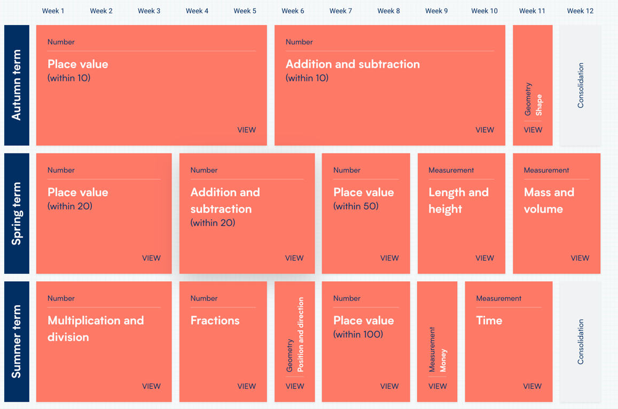

Year 1
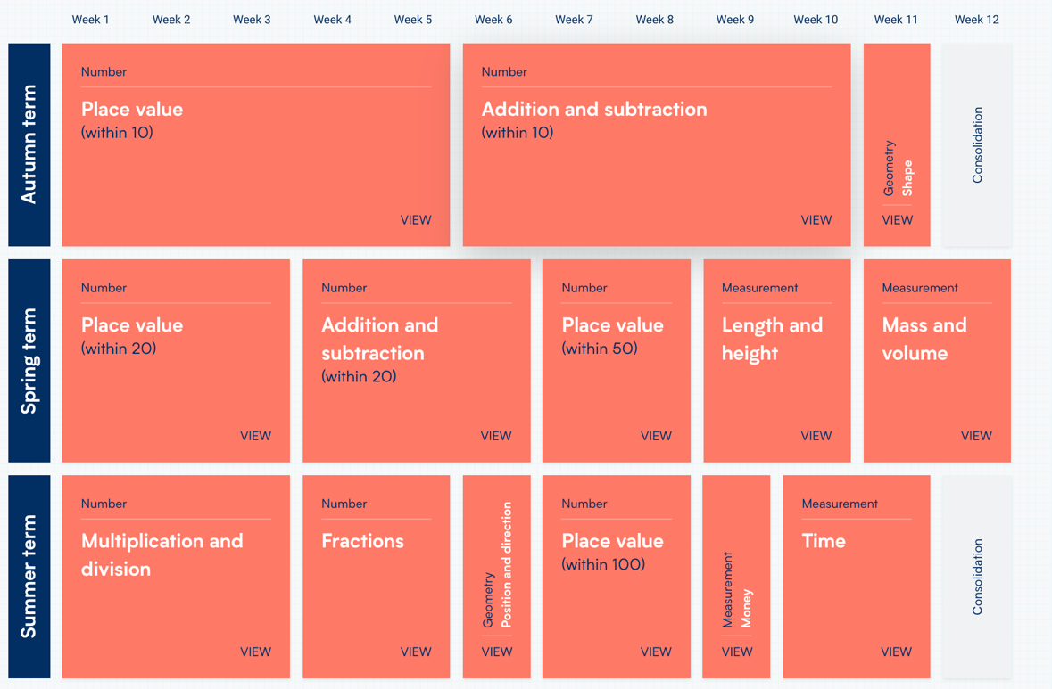
Year 2
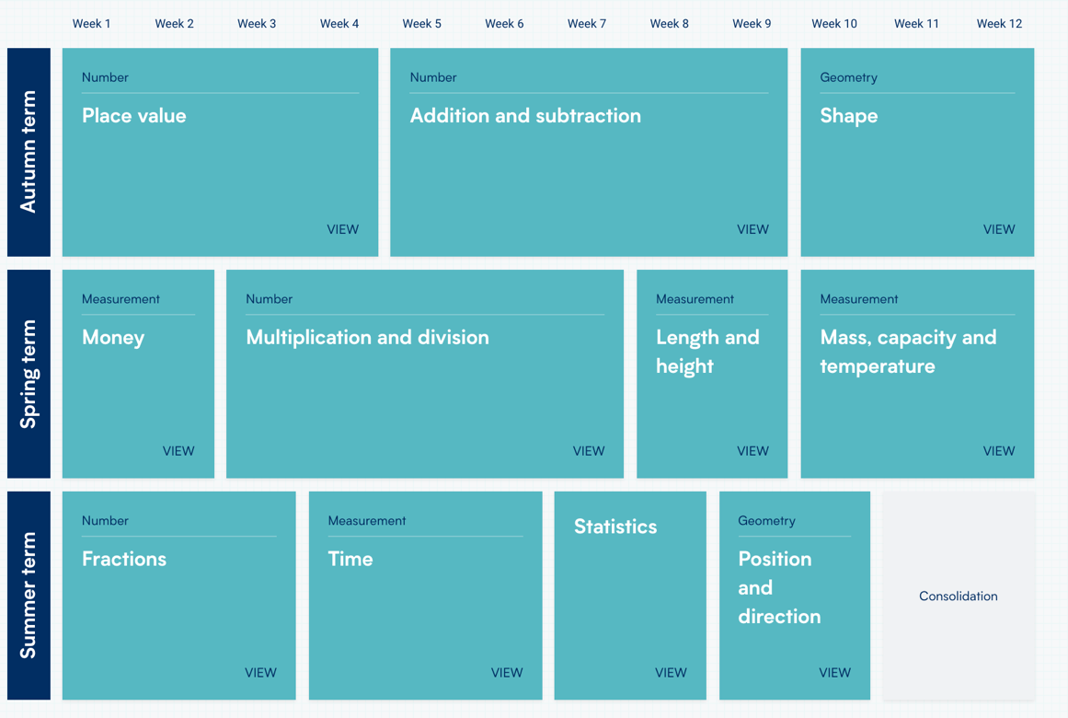
Year 3
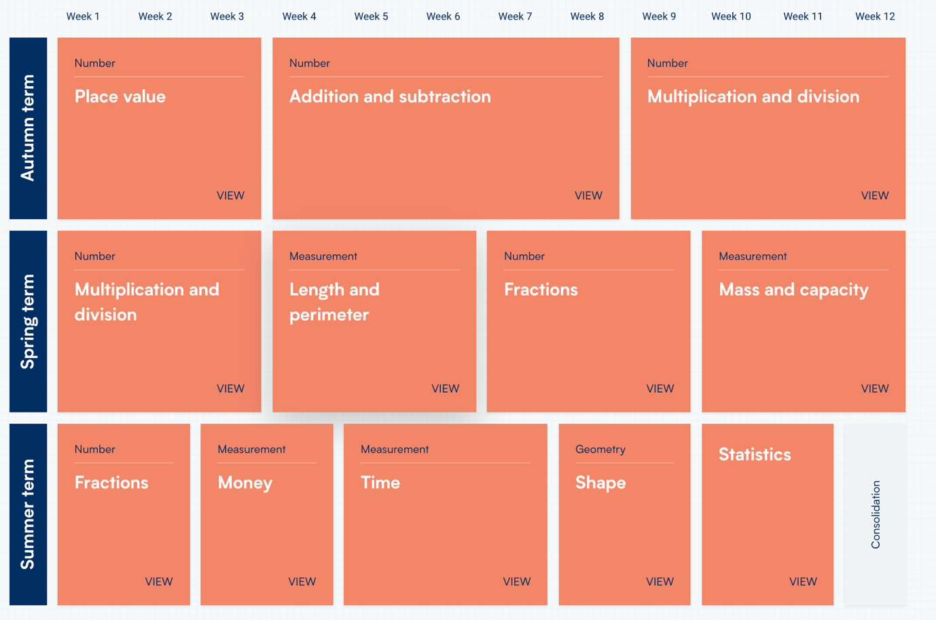
Year 4
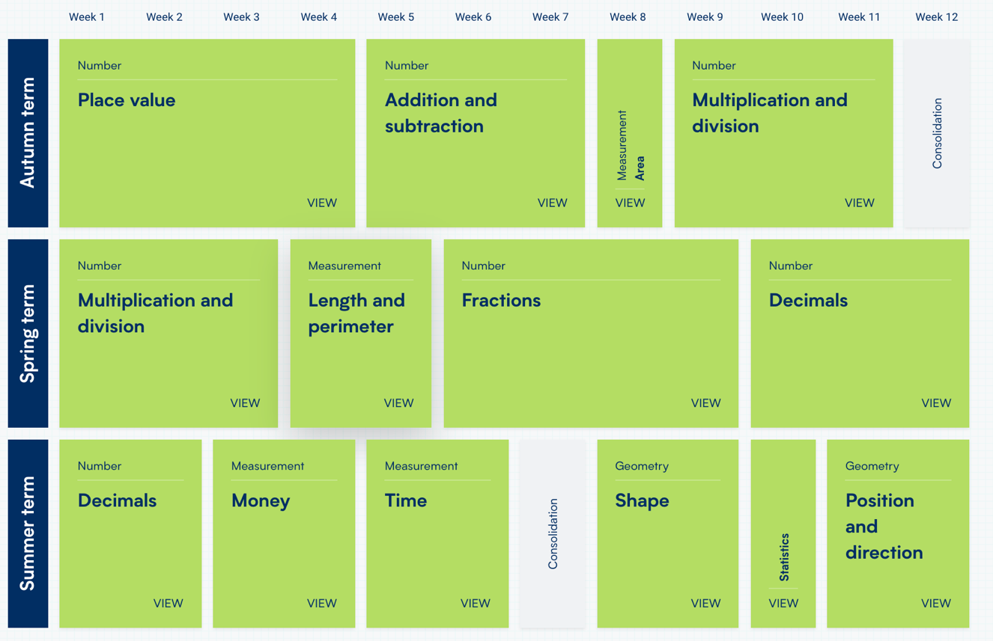

Year 5
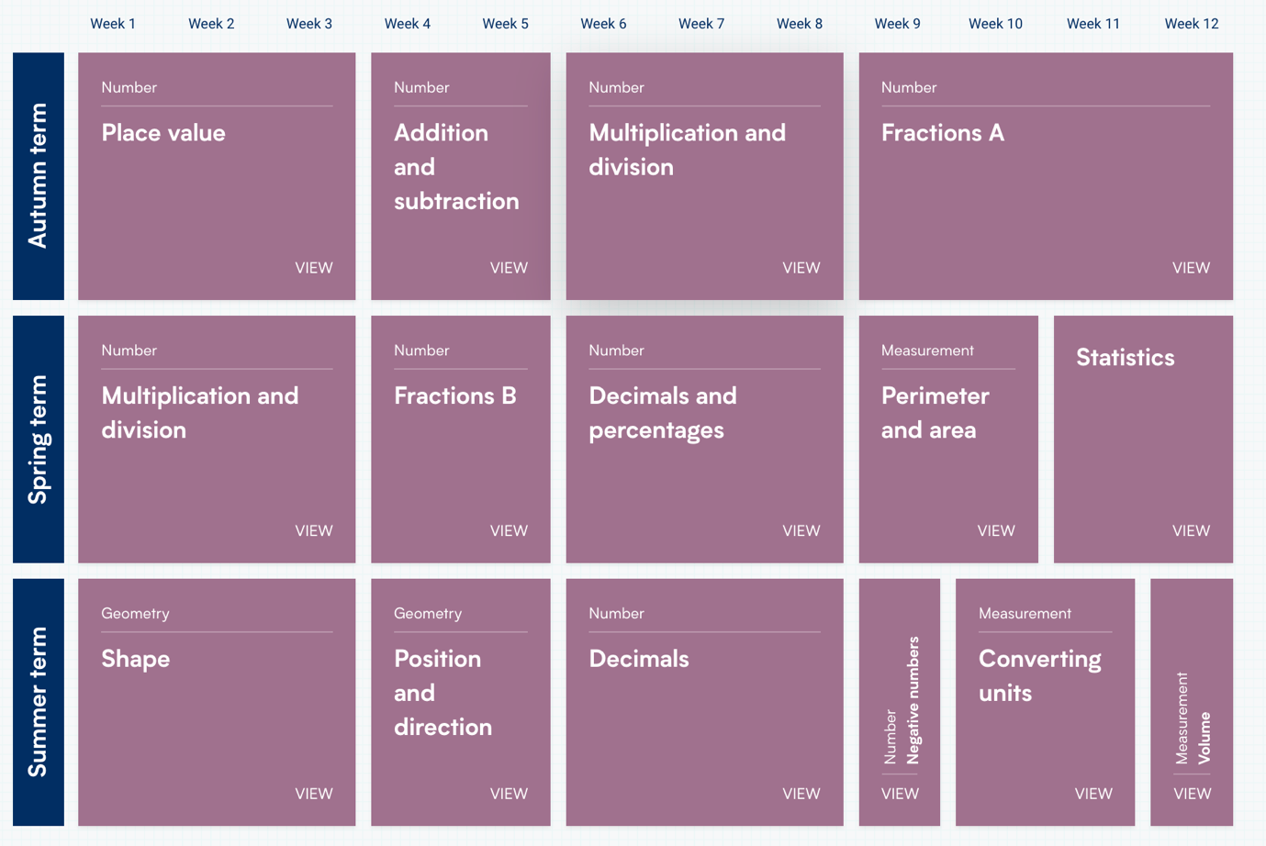
Year 6
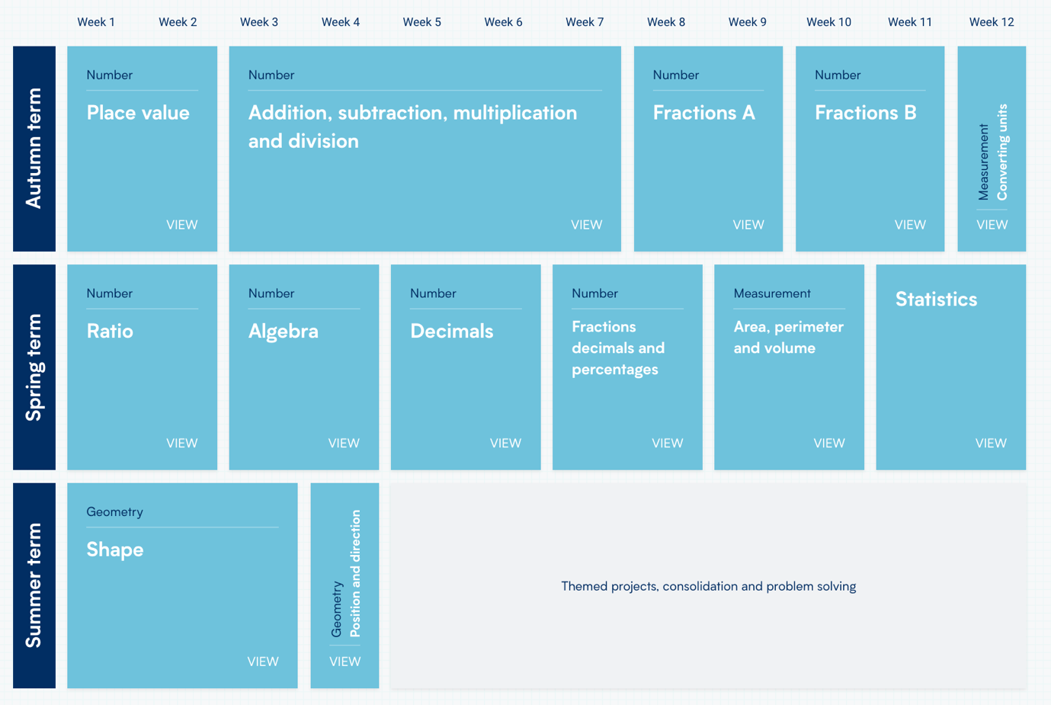
Vocabulary
Below is a comprehensive list of all the vocabulary children will and could be exposed to in their year group. Each year should be progressing through the vocabulary list, building on their prior knowledge.
Reception | In the Foundation Stage, language is mostly spoken. Of course this does not mean that children should not have sight of the written word, but preferably this should always be in conjunction with the appropriate imagery so that they can begin to associate and recognise words they cannot necessarily yet read fluently.
Y1 | Number and Calculation same different count(ing) forwards backwards share left over more (than) less (than) total fewer (than) equal (to) most least sum difference distance between total first plus add(ition) subtract(ion) minus ones tens column(s) multiples twenty one twenty two twenty three (and so on up to) ninety nine one hundred first second third fourth (and so on up to) nineteenth twentieth order number amount value size odd even numberline double halve pair how much how many larger smaller estimate compare together altogether bonds zero between above below  Fractions (one) half (one) (two) )three) quarters sharing group (ing) part whole equal parts same size bar  Measurement (time, mass, length, capacity, money)  TIME year month week weekend day Monday Tuesday Wednesday Thursday Friday Saturday Sunday January February March April May June July August September October November December night hour minute second morning afternoon evening yesterday today tomorrow before after old(er) new(er) clock (face) o’clock half past birthday watch hour (hand) minute (hand) minutes past/to quarter past/to half past/to fast(er) quick(er) slow(er) early earlier late later  MASS weigh weight heavy heavier (than) heaviest light lighter (than) lightest balance (weighing) scales ruler  LENGTH long(er)(est) short(er)(est) gram/g kilogram/kg centimetre/cm metre/m far distance measure long(er)(est) short(er)(est)  CAPACITY volume full empty more than less than half full  MONEY coin note amount penny/p pound/£ coin values: one pence two pence Five pence ten pence twenty pence fifty pence  Geometry  SHAPE PROPERTIES pattern 2-D rectangle square circle triangle 3-D cube cuboid pyramid sphere side(s)  POSITION AND DIRECTION left right top middle bottom in front of behind between above below around near close far up down forwards backwards inside outside clockwise
Y2 | Number and Calculation digit numeral twenty one twenty two twenty three twenty four and so on up to ninety nine one hundred multiple commutative place value step counting > as ‘greater than’ < as ‘less than’ partition place holder place value estimate estimation inverse array calculate multiplication division times tables  Fractions (one) (two) third(s) sharing grouping two quarters third one third two thirds equivalent ‘one and a quarter’ one and 2 quarters one and a half one and 3 quarters half as much twice as much numerator denominator  Measurement (time, mass, length, capacity, temperature, money)  TIME analogue Five/ten/1/4 pas/to clockwise anticlockwise  MASS gram kilogram  LENGTH height width metre centimetre millimetre  CAPACITY litre millilitre  TEMPERATURE degrees Celsius thermometer
Y3 | Number and Calculation hundreds one hundred and one one hundred and two one hundred and three and so on up to one thousand multiple(s) inverse operations integer(s) decimal(s) remainder  Fractions fifths sixths sevenths eighths ninths tenths numerator denominator order unit-fraction non-unit fraction  Measurement millimetre perimeter roman numerals to XII am/pm duration noon midnight analogue clock digital clock  Geometry orientation degree(s) right angle perpendicular parallel horizontal vertical quadrilateral polygon polyhedron polyhedral acute obtuse reflex reflection  Statistics interpret data category(ies) scale
Y4 | Number and Calculation thousands round rounding Roman numerals to 100 ‘C’ negative operation factor factor pairs distributive associative derive remainder  Fractions hundredth(s) ‘decimal equivalents decimal places proportion  Measurement convert conversion rectilinear area dimensions kilometre 24-hour clock  Geometry orientation degree(s) right angle perpendicular parallel horizontal vertical quadrilateral classify polygon pentagon hexagon heptagon octagon nonagon decagon polyhedron polyhedra acute obtuse isosceles scalene equilateral parallelogram rhombus trapezium protractor regular irregular reflex coordinates quadrant plot grid translate translation axis/axes scale  Statistics label graph
Y5 | Number and Calculation million(s) Roman numerals to 1000 ‘M’ linear sequence power(s) prime complement composite prime factor square(d)2 cube(d)3 equivalence  Fractions mixed number(s) thousandths percent percentage(s)  Measurement composite metric imperial inch foot yard mile pound (lb) pint cm2 cm3 m2 m3  Geometry orientation degree(s) right angle perpendicular parallel diagonal horizontal vertical quadrilateral polygon polyhedron polyhedra acute obtuse reflex point reflection 180o 360o X-axis Y-axis  Statistics interpret data category(ies) scale
Y6 | Number and Calculation factorise, prime, prime factor  Fractions thousandth  Data mean, average, median, statistics, distribution  Geometry circumference, intersecting, intersection  Measurement centilitre

Mickleton Fluency Progression Facts from Y1-6
Year 1
Count to 100
Count in 2’s 5’s 10’s
All number bonds up to 10, e.g. 7+2 = 9 and 9-2=7
1 more or less
Use and label number line up to 10
Doubles and halves up to 20
Know if a number is odd or even

Year 2
Count in 3’s 5’s
Count in 10’s from any number back and forward
All number bonds to 20
Use a bar model or use a part / whole model for simple add / sub
Fact families for add / sub
Know that to add 11 is to add 10 then 1
Know that to add 9 is to add 10 then – 1
Times and division Tables: 2,5,10
Doubles and halves up to 100
Count in halves up to 10

Year 3
Count in 4’s 8’s 50’s 100’s
Find 10 or 100 more and less than a given number
Use a part/whole model and bar model for mult and div
Count up and down in tenths
Know how to add “nearly” numbers like 39, 99, 101, 71 etc
Multiply any 1 or 2 digit number by 10
Know that to multiply by 5, you multiply by 10 then half
Mentally add a ones, tens or hundreds number to 3 digit no.
Fact families for mult / div
Know that to multiply by 4 you can double and double again
Times and division Tables: 3,4,8,11

Year 4
Count back through 0 inc. negative numbers
Count in 6’s 7’s 9’s 25’s 1000
Count up and down in hundredths
Number bonds to 100 (change from £1)
Find 1000 more or less
Times and division Tables: 6,7,9,12
Mentally multiply 3 numbers
Multiply mentally by partitioning

Year 5
Count forwards and back through 0
Count forwards and back using powers of 10
Number bonds to 1
Multiply any number up to 1 d.p by 10, 100 and 1000
Use mental strategies to add 2 and 3 digit tens numbers
Convert most common FDP mentally

Year 6
Count in tenths and hundredths in fractions and decimals
Perform mental calculations, including with mixed operations and large numbers
Convert F D P

Use more complicated mental strategies to solve calculations. i.e. 36 x 8=(30x8) + (6x8)
Mentally mult and div using known strategies i.e 13 x 8 = (10x8) + (3x8)
Know factors and multiples of numbers up to 100 for factors and 12 for multiples Learn tricks for finding factors i.e. adding digits for 3 and 9 etc
Simplify fractions

Greater Depth
What is Mastery?
A child’s ability to skilfully apply their learning in more in‐depth ways is called Mastery. Mastery is not just knowing a fact, but it is using that fact in increasingly more complex situations to extend their learning. Mastery also enables children to work in ways which show a deeper understanding of a given task.
What is Mastery in Maths?
Mastery in Maths is being able to apply knowledge to other areas of their learning. Children can also problem solve, reason and explain their understanding clearly.
Examples of Cultural Capital in Maths:
- Theme days to explore concepts more widely
- Cross-curricular learning
- Use of the outdoor learning environment
- Use of resources to provide ‘hands on’ learning
- Opportunities to ask questions and research and explore answers
- Problem solving is taught weekly to allow children chance to apply learning
- Become naturally curious about the world around them
- Develop the skills of enquiry and investigation
- Promote enjoyment and enthusiasm for learning about the world around them from an early age – Business week, real life examples
- Learn and use more mathematical vocabulary as this is explicitly taught.
- Develop excitement and interest during Theme Days and Cross curricular lessons

