Home-learning Project – All about JK Rowling and Harry Potter

- TASK 1 – AUTHOR STUDY

Create a Fact File on J.K. Rowling. Research the following: •
- 10 facts about the author
- Other novels/works by this author
- Memorable quotes from the author’s novels
- What do you like about this author?

Ensure that your Fact File is presented neatly and clearly. Presentation is important. Can you add images/drawings where appropriate?

- TASK 2 – CREATE YOUR OWN HOUSE LOGO
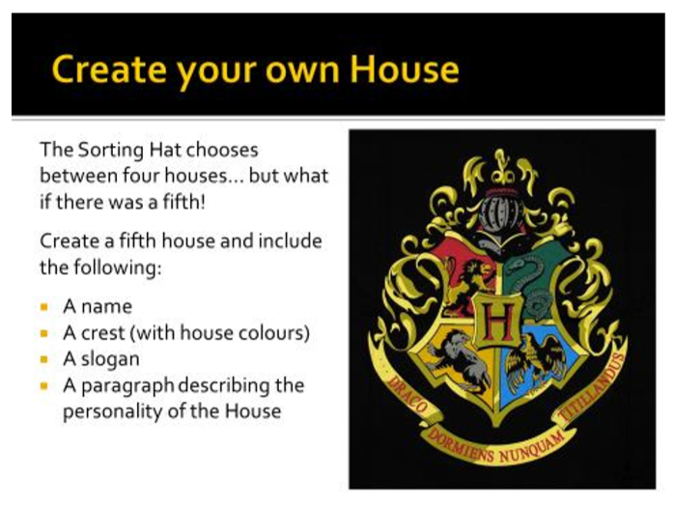

Ensure that the paragraph that describes the personality of your house is at least 80-100 words.
What kinds of people do you allow into your House?
Below is an example:
Gryffindor: The house of the brave, loyal and courageous; the house of the adventurous, daring and chivalrous. Those who stand up for others typically belong in the Gryffindor House. Individuals who demonstrate resilience, bravery and compassion belong in Gryffindor since these are all skills that members must possess in order to perform well at Hogwarts. The ability to succeed in witchcraft is necessary but, above all else, the ability to be a compassionate and caring individual is of utmost importance.

- TASK 3 – A HOGWARTS GHOST STORY
Hogwarts is full of ghosts. Your task is to write a ghost story based in Hogwarts. It could be about Moaning Myrtle, The Fat Friar or Nearly Headless Nick. Make sure that you plan your story before you begin. In addition, make sure you plan your story so that it builds tension and suspense and ends on a cliff-hanger. Think about your characters and setting. REMEMBER: choose a suitable location.

- TASK 4 – Analyse a passage from the book.

Using the extract below, respond to the question:

How does the writer create a strong atmosphere here?

Write a few sentences to answer the question.

Think about: • Punctuation (how does the punctuation used create tension? How does the use of a dash create tension by encouraging the reader to pause?) • Language (How does the language used engage the novel’s readers?)

Use the sentence starters below to help you get started:
- One method the writer uses to create a strong atmosphere in the extract is…
- Another way in which a strong atmosphere is created is through the use of… ➢
- The use of punctuation allows for an interesting atmosphere to be created: [insert quote here]
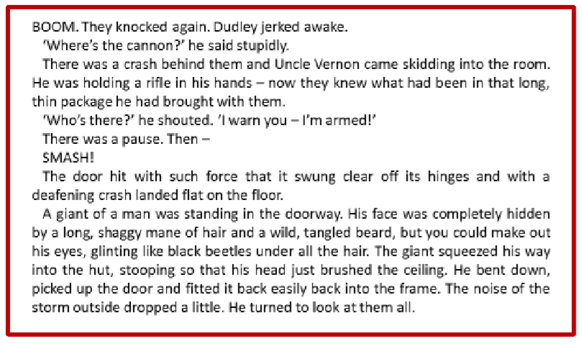

Extra Challenge ideas:
- Use any form of art, colours, pens, pencils, collage to make your crest design.
- Invent a House Meal, and then prepare it.
- Invent a quiz to test whether people can join your house.
- Build a den in your house or garden, to be your house common room. Decorate it with the colours and objects relating to your house.
- What pets would your house pupils have? Describe and draw them.

